Question No .01

Input

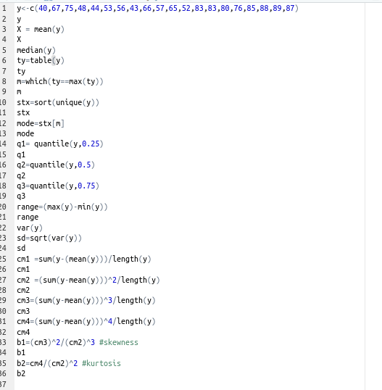

Out put

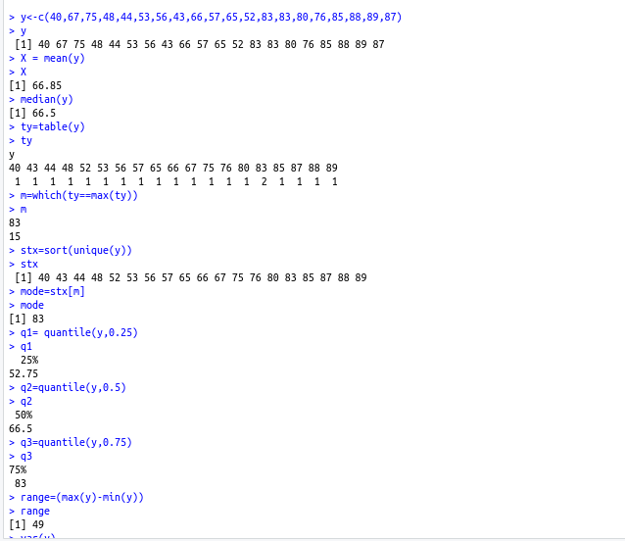

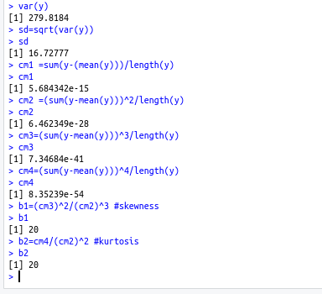

Question .2

Input

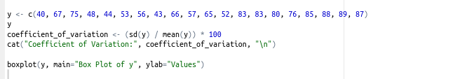

Out put

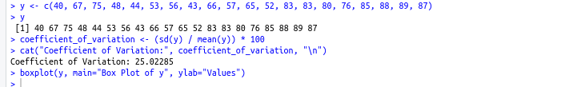

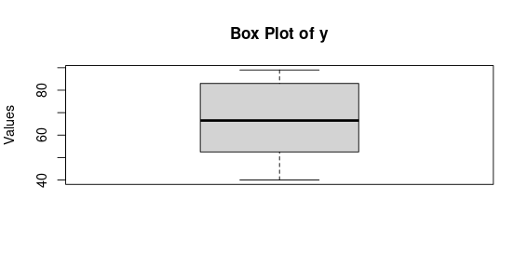

Question no .03

Input

items <- c("Food", "Clothing", "Rent", "Fuel and Lighting", "Education", "Miscellaneous")

expenditures <- c(240, 66, 125, 57, 42, 190)

pie(expenditures, labels = items, main = "Expenditure by items ", col = rainbow(length(expenditures)))

Out put

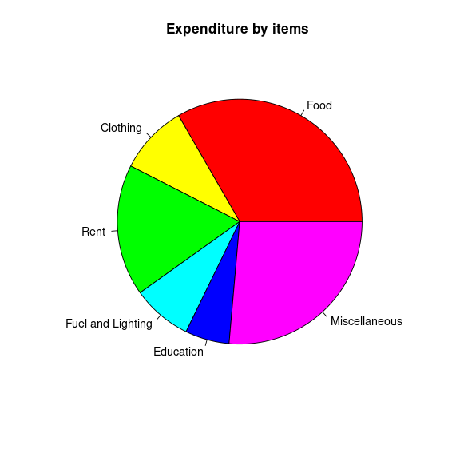

# Question No .04

Input



Out

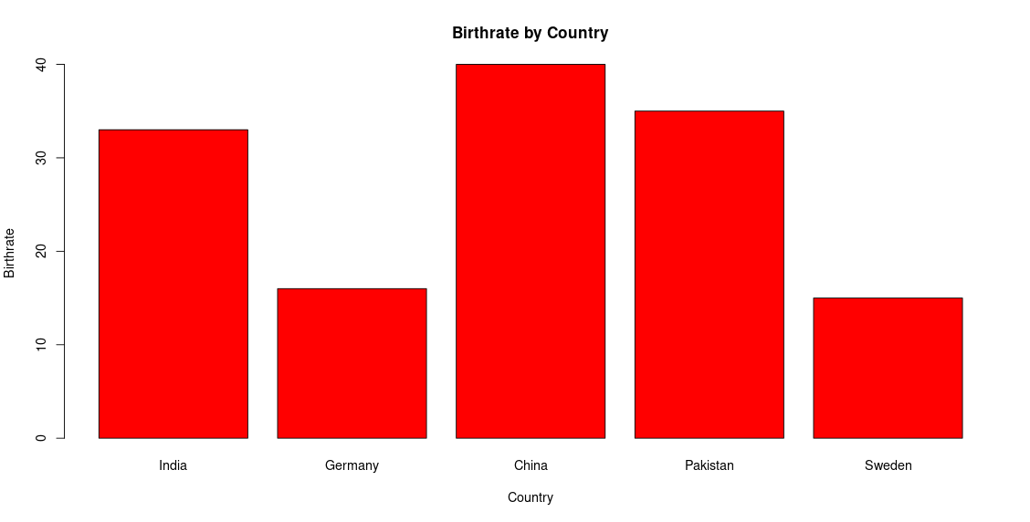

# Question no.10

Input

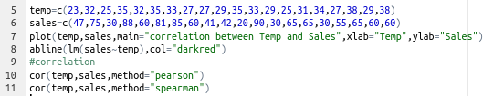

Out put

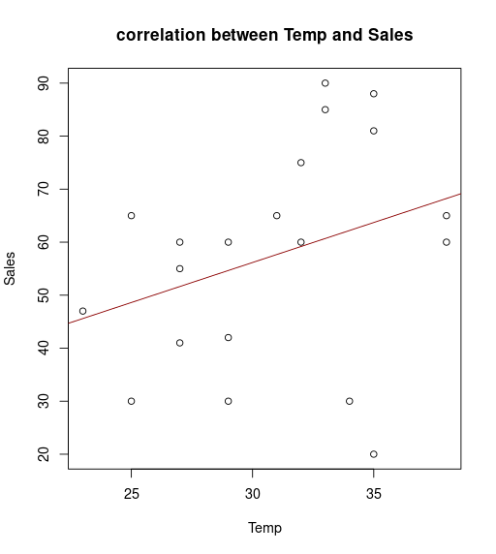

# Question .no .05

Input

year <- c("2000-2001", "2000-2001", "2000-2001", "2001-2002", "2001-2002", "2001-2002", "2002-2003", "2002-2003", "2002-2003")

marks <- c(20, 10, 5, 25, 9, 10, 30, 20, 20)

stream <- c("Arts", "Science", "Low", "Arts", "Science", "Low", "Arts", "Science", "Law")

barplot(marks, names.arg = year, main = "Marks by Year", xlab = "Year", ylab = "Marks", col = ifelse(stream == "Arts", "green", ifelse(stream == "Science", "orange", "black")))

Output

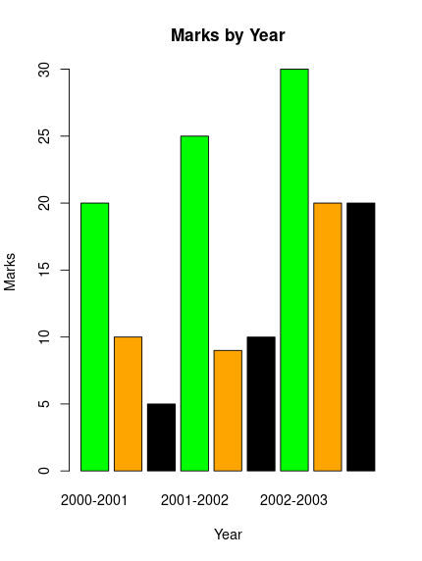

# Question no. 06

Input

marks <- c(5, 15, 25, 35, 45)

students <- c(6, 12, 25, 16, 11)

plot(marks, students, type = "o", pch = 19, col = "Red", xlab = "Marks", ylab = "Students")lines(marks, students, type = "o", pch = 19, col = "Red")

Output

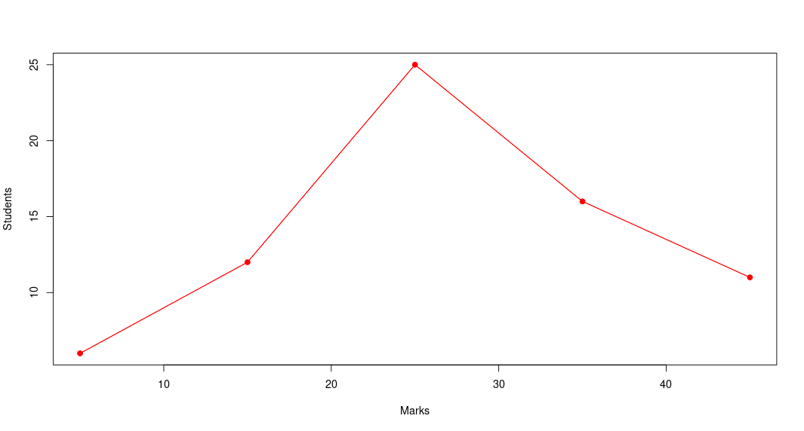

# Question no. 07

Input

city <- c("Delhi", "Kolkata", "Mumbai", "Chennai", "Delhi", "Kolkata", "Mumbai", "Chennai")

temperature <- c(40.5, 42.8, 37.8, 39.4, 34.7, 33.5, 33.2, 33.1)

Level <- c("Max", "Max", "Max", "Max", "Min", "Min", "Min", "Min")

barplot(matrix(temperature, nrow = 2, byrow = TRUE), beside = TRUE, col = c("orange", "green"), names.arg = city, main = "Subdivided Bar Diagram", xlab = "City", ylab ="Temperature")

Output

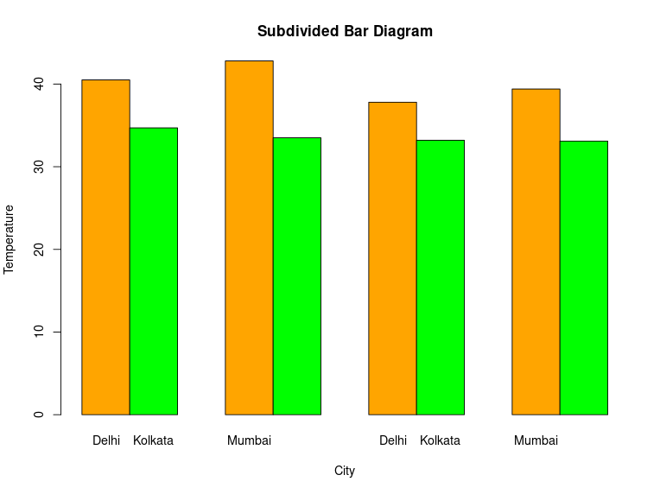

Question no .08

Input part (a)

x=c(5.1,3.2,8.5,3.5,9.2,5.5,8.3,2.7,7.7,5.9,4.5,3.3,8.9,2.5,6.1,7.4,2.7,4.8,6.9,7.8)

x

y=c(47,75,30,88,60,81,85,60,41,42,20,90,30,65,65,30,55,65,60,60)

y

model=lm(y~x)

model

summary(model)

plot(x,y,main = "Scores per hour",xlab=("Hours"),ylab=("Scores"))

abline(model,col="blue")

Output

| x=c(5.1,3.2,8.5,3.5,9.2,5.5,8.3,2.7,7.7,5.9,4.5,3.3,8.9,2.5,6.1,7.4,2.7,4.8,6.9,7.8)  >  > x  [1] 5.1 3.2 8.5 3.5 9.2 5.5 8.3 2.7 7.7 5.9 4.5 3.3 8.9 2.5 6.1 7.4 2.7 4.8 6.9 7.8  >  > y=c(47,75,30,88,60,81,85,60,41,42,20,90,30,65,65,30,55,65,60,60)  >  > y  [1] 47 75 30 88 60 81 85 60 41 42 20 90 30 65 65 30 55 65 60 60  >  > model=lm(y~x)  >  > model  Call:  lm(formula = y ~ x)  Coefficients:  (Intercept) x  76.736 -3.369  >  > summary(model)  Call:  lm(formula = y ~ x)  Residuals:  Min 1Q Median 3Q Max  -41.58 -13.20 0.56 10.72 36.23  Coefficients:  Estimate Std. Error t value Pr(>|t|)  (Intercept) 76.736 12.231 6.274 6.46e-06 ***  x -3.369 1.993 -1.690 0.108  ---  Signif. codes: 0 ‘***’ 0.001 ‘**’ 0.01 ‘*’ 0.05 ‘.’ 0.1 ‘ ’ 1  Residual standard error: 19.71 on 18 degrees of freedom  Multiple R-squared: 0.137, Adjusted R-squared: 0.08904  F-statistic: 2.857 on 1 and 18 DF, p-value: 0.1082  >  > plot(x,y,main = "Scores per hour",xlab=("Hours"),ylab=("Scores"))  >  > abline(model,col="blue") |
| --- |
|  |
| Part (b)  Input |
| x=c(22,20,21,20,23,18,19,20)  x  y=c(40.5,42.8,37.8,39.4,34.7,33.5,32.2,33.1)  y  model=lm(y~x)  model  summary(model)  plot(x,y,main="Weight by Age plot",xlab =("Age"),ylab=("Weight"))  abline(model,col="purple")  OUTPUT  x=c(22,20,21,20,23,18,19,20)  > x  [1] 22 20 21 20 23 18 19 20  > y=c(40.5,42.8,37.8,39.4,34.7,33.5,32.2,33.1)  > y  [1] 40.5 42.8 37.8 39.4 34.7 33.5 32.2 33.1  > model=lm(y~x)  > model  Call:  lm(formula = y ~ x)  Coefficients:  (Intercept) x  21.4189 0.7524  > summary(model)  Call:  lm(formula = y ~ x)  Residuals:  Min 1Q Median 3Q Max  -4.0252 -3.4047 -0.4416 2.6285 6.3322  Coefficients:  Estimate Std. Error t value Pr(>|t|)  (Intercept) 21.4189 19.4750 1.100 0.314  x 0.7524 0.9533 0.789 0.460  Residual standard error: 4.03 on 6 degrees of freedom  Multiple R-squared: 0.09407, Adjusted R-squared: -0.05691  F-statistic: 0.6231 on 1 and 6 DF, p-value: 0.46  > plot(x,y,main="Weight by Age plot",xlab =("Age"),ylab=("Weight"))  > abline(model,col="purple")    #Question no .09  Input  Temperature=c(23,32,25,35,32,35,33,27,27,29,35,33,29,25,31,34,27,38,29,38)  Temperature  Sales=c(47,75,30,88,60,81,85,60,41,42,20,90,30,65,65,30,55,65,60,60)  Sales  model=lm(Sales~Temperature)  model  summary(model)  plot(Temperature,Sales)  abline(model,col="red")  OutPut  Temperature=c(23,32,25,35,32,35,33,27,27,29,35,33,29,25,31,34,27,38,29,38)  >  > Temperature  [1] 23 32 25 35 32 35 33 27 27 29 35 33 29 25 31 34 27 38 29 38  >  > Sales=c(47,75,30,88,60,81,85,60,41,42,20,90,30,65,65,30,55,65,60,60)  >  > Sales  [1] 47 75 30 88 60 81 85 60 41 42 20 90 30 65 65 30 55 65 60 60  >  > model=lm(Sales~Temperature)  >  > model  Call:  lm(formula = Sales ~ Temperature)  Coefficients:  (Intercept) Temperature  10.87 1.51  >  > summary(model)  Call:  lm(formula = Sales ~ Temperature)  Residuals:  Min 1Q Median 3Q Max  -43.716 -11.142 2.382 15.956 29.304  Coefficients:  Estimate Std. Error t value Pr(>|t|)  (Intercept) 10.873 32.975 0.330 0.745  Temperature 1.510 1.059 1.426 0.171  Residual standard error: 20.11 on 18 degrees of freedom  Multiple R-squared: 0.1015, Adjusted R-squared: 0.05156  F-statistic: 2.033 on 1 and 18 DF, p-value: 0.171    > plot(Temperature,Sales)  > abline(model,col="red") |
|  |